DOCUMENTATION
MySQL Assignment 2 – Querying Data
INSERTING DATA
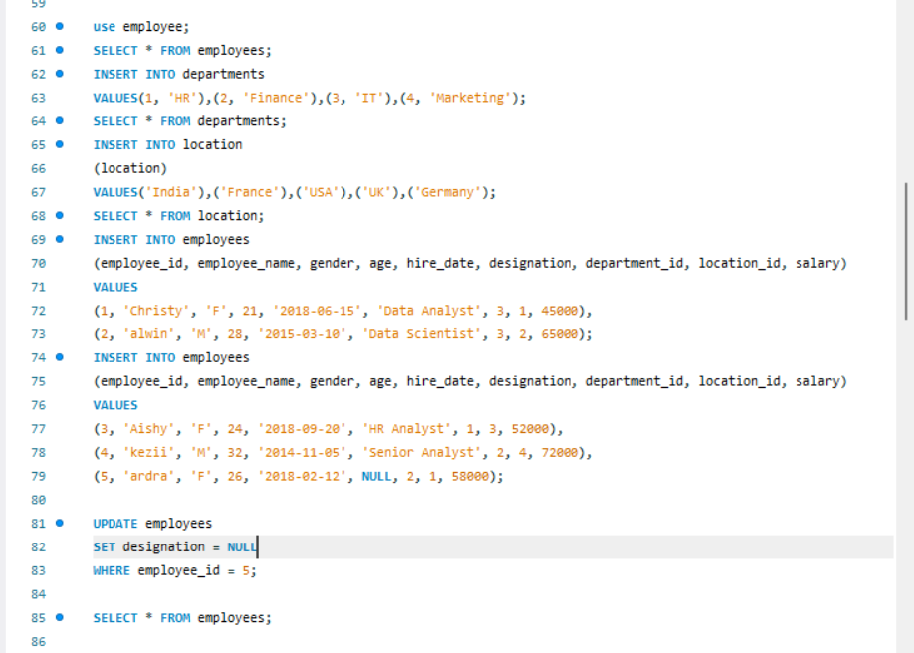
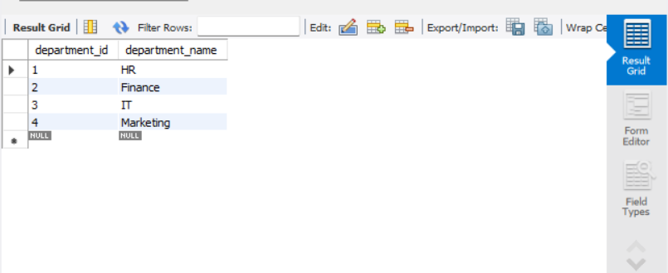

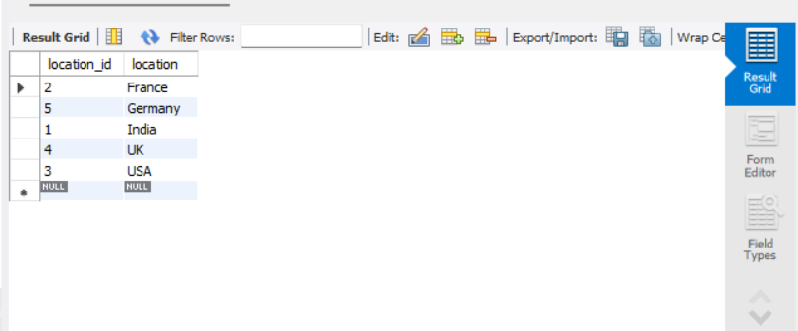

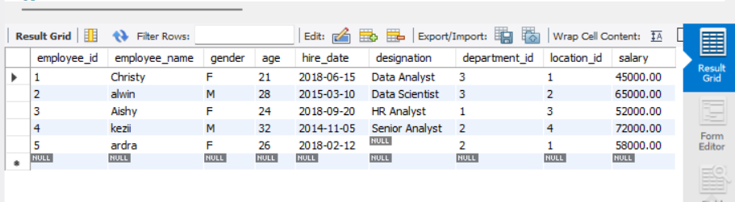

Distinct Values:
a query to retrieve distinct salaries from the Employees table.

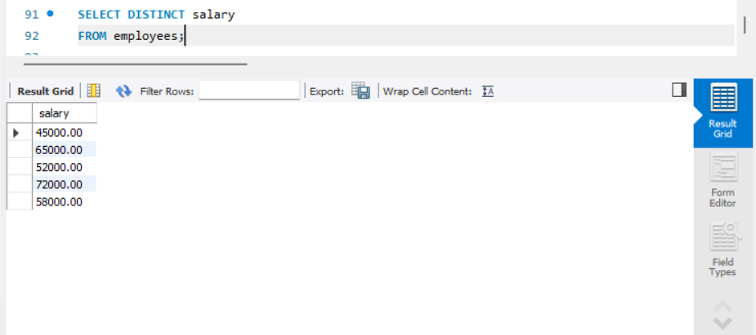
Alias (AS):
Provide aliases for the "age" and "salary" columns as "Employee_Age" and "Employee_Salary", respectively.

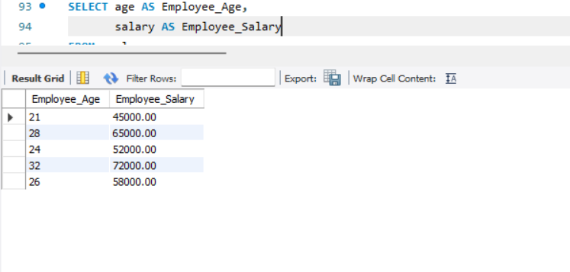

Where Clause & Operators:
Retrieve employees with a salary greater than ₹50000 and hired before 2016-01-01.

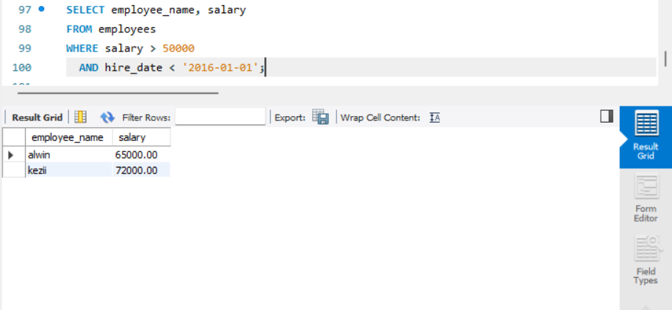

Find the employee whose designation is missing and fill it with "Data Scientist".

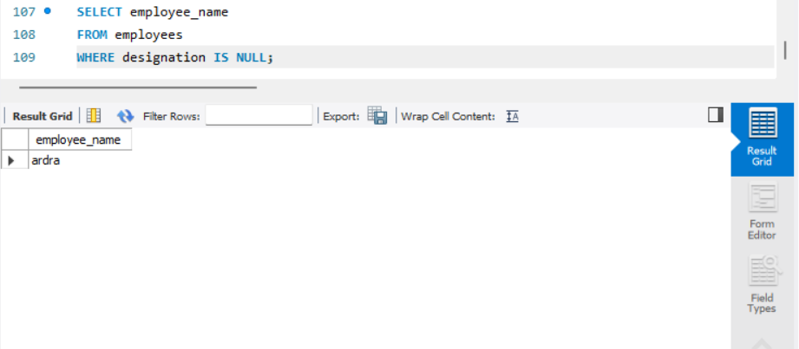

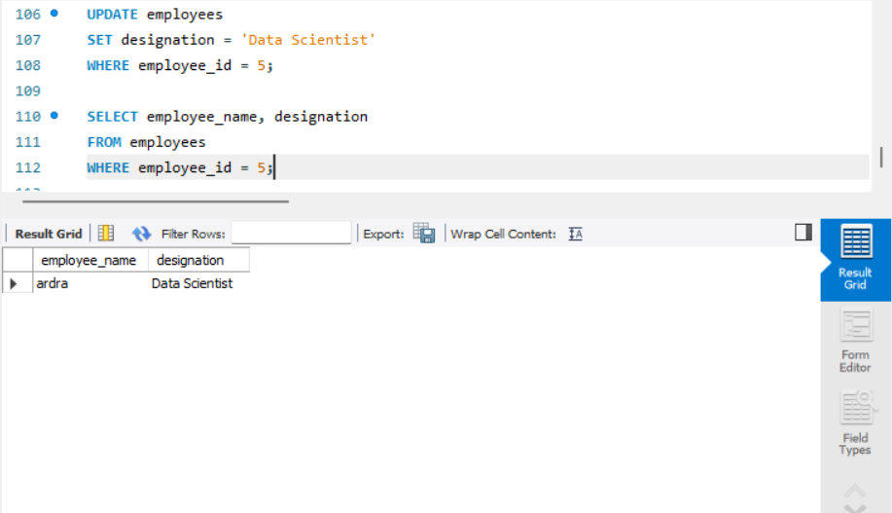
Sorting and Grouping Data:
ORDER BY:
Find employees sorted by department ID in ascending order and salary in descending order.
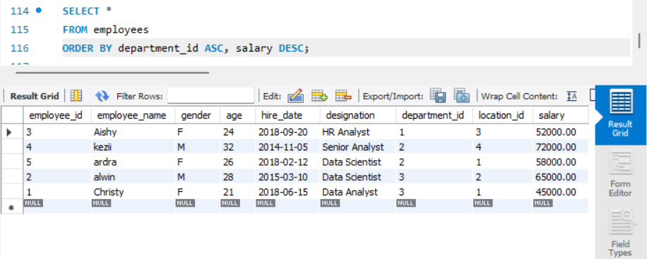

LIMIT:
Display the first 5 employees hired in the year 2018.
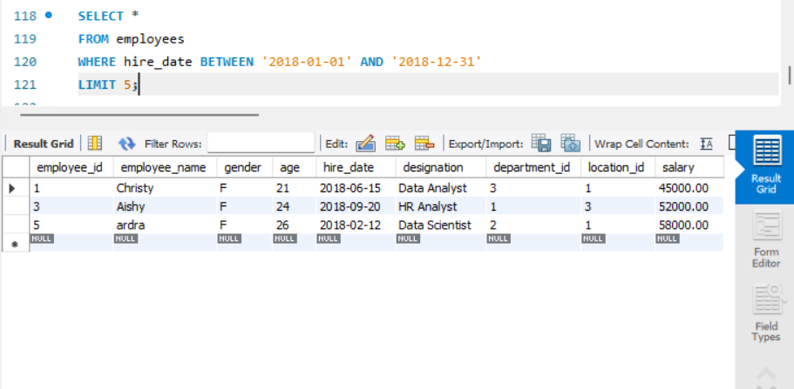

Aggregate Functions:
Calculate the sum of all salaries in the Finance department.
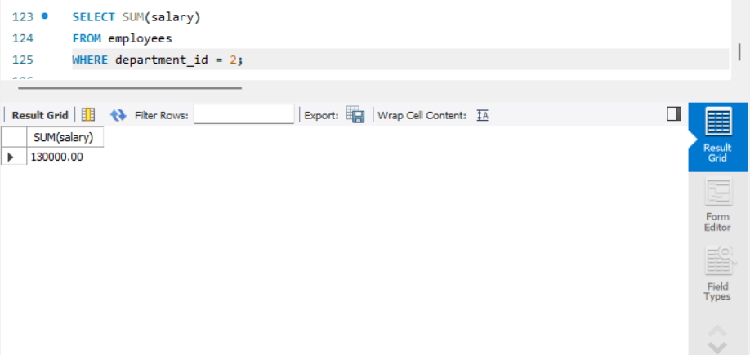

Find the minimum age among all employees.
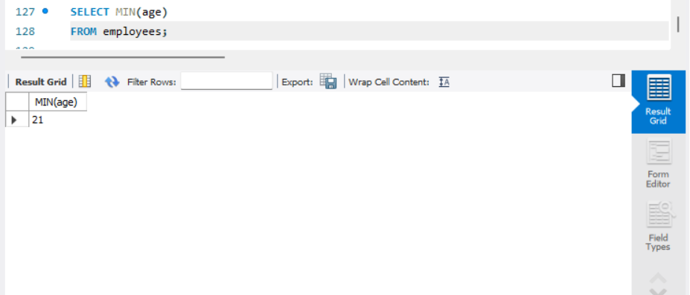

GROUP BY:

List the maximum salary for each location.
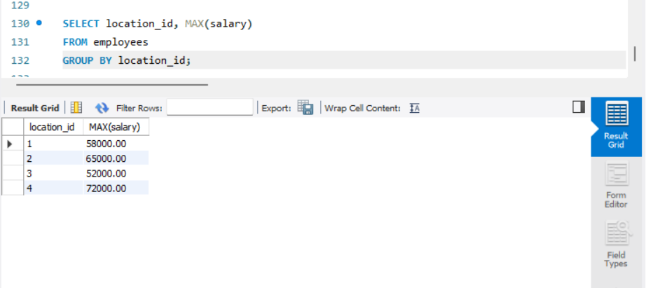

Calculate the average salary for each designation containing the word 'Analyst'.
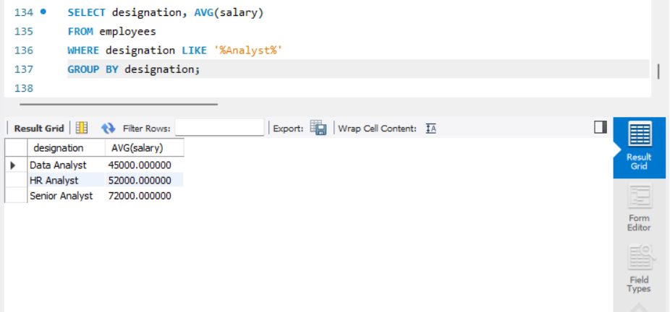

HAVING:
Find departments with less than 3 employees.
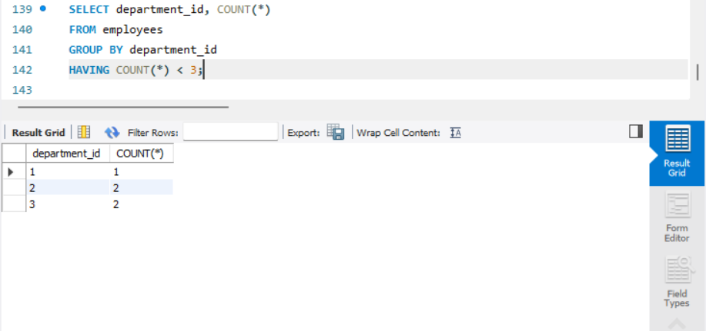
Find locations with female employees whose average age is below 30.
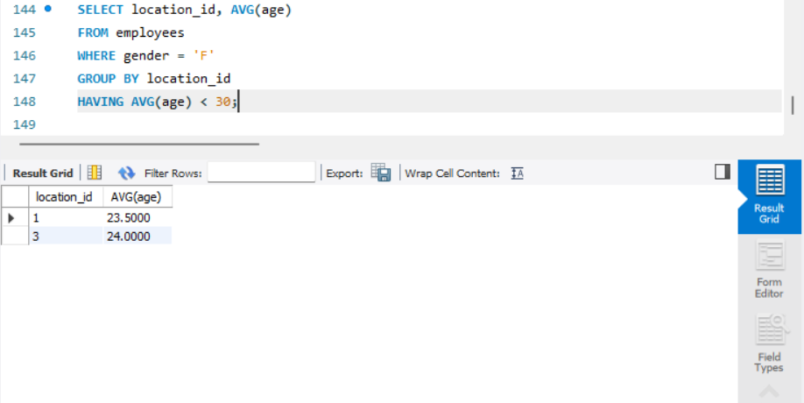

Joins:
Inner Join:
List employee names, their designations, and department names where employees are assigned to a department.
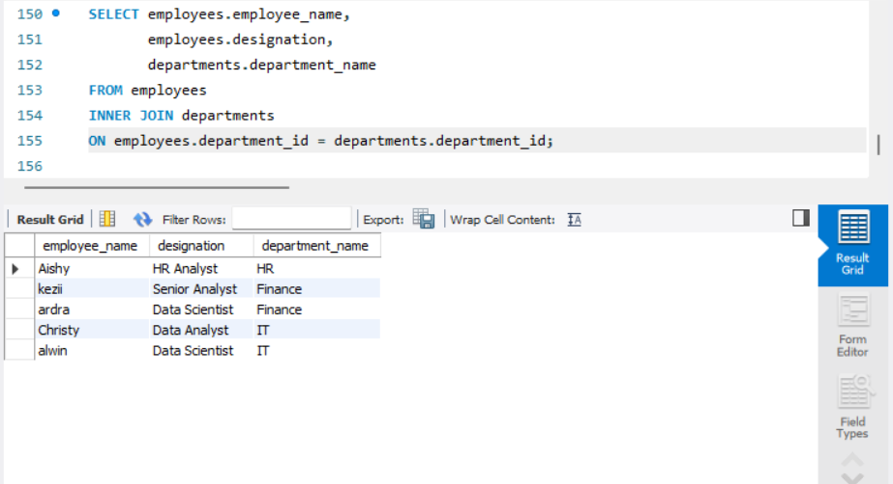

Left Join:
List all departments along with the total number of employees in each department, including departments with no employees.
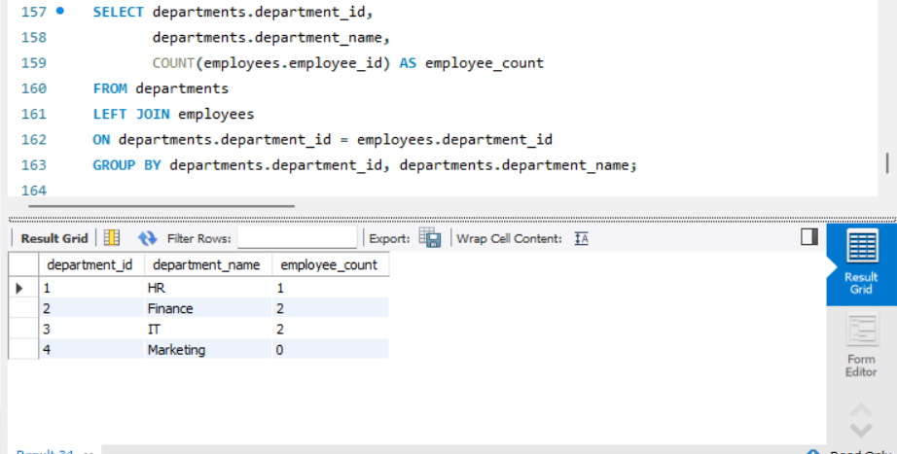
Right Join:
Display all locations along with the names of employees assigned to each location. If no employees are assigned to a location, display NULL for employee name.

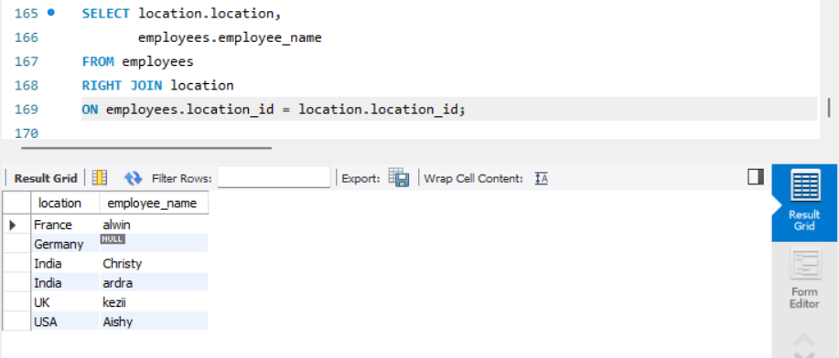

CODE :
use employee;
SELECT * FROM employees;
INSERT INTO departments
VALUES(1, 'HR'),(2, 'Finance'),(3, 'IT'),(4, 'Marketing');

SELECT * FROM departments;

INSERT INTO location(location)
VALUES ('India'),('France'),('USA'),('UK'),('Germany');

SELECT * FROM location;

INSERT INTO employees(employee_id, employee_name, gender, age, hire_date, designation, department_id, location_id, salary)
VALUES (1, 'Christy', 'F', 21, '2018-06-15', 'Data Analyst', 3, 1, 45000),
(2, 'alwin', 'M', 28, '2015-03-10', 'Data Scientist', 3, 2, 65000);

INSERT INTO employees(employee_id, employee_name, gender, age, hire_date, designation, department_id, location_id, salary)
VALUES(3, 'Aishy', 'F', 24, '2018-09-20', 'HR Analyst', 1, 3, 52000),
(4, 'kezii', 'M', 32, '2014-11-05', 'Senior Analyst', 2, 4, 72000),
(5, 'ardra', 'F', 26, '2018-02-12', NULL, 2, 1, 58000);

UPDATE employees
SET designation = NULL
WHERE employee_id = 5;

SELECT * FROM employees;

SELECT DISTINCT salary
FROM employees;

SELECT age AS Employee_Age,
salary AS Employee_Salary
FROM employees;

SELECT employee_name, salary
FROM employees
WHERE salary > 50000
AND hire_date < '2016-01-01';

SELECT employee_name, designation
FROM employees
WHERE employee_id = 5;

SELECT *FROM employees
ORDER BY department_id ASC, salary DESC;

SELECT *FROM employees
WHERE hire_date BETWEEN '2018-01-01' AND '2018-12-31' LIMIT 5;

SELECT SUM(salary)
FROM employees
WHERE department_id = 2;

SELECT MIN(age)
FROM employees;

SELECT location_id, MAX(salary)
FROM employees
GROUP BY location_id;

SELECT designation, AVG(salary)
FROM employees
WHERE designation LIKE '%Analyst%'
GROUP BY designation;

SELECT department_id, COUNT(*)
FROM employees
GROUP BY department_id
HAVING COUNT(*) < 3;

SELECT location_id, AVG(age)
FROM employees
WHERE gender = 'F'
GROUP BY location_id
HAVING AVG(age) < 30;

SELECT employees.employee_name,employees.designation,
departments.department_name
FROM employees
INNER JOIN departments
ON employees.department_id=departments.department_id;

SELECT departments.department_id,
departments.department_name,
COUNT(employees.employee_id) AS employee_count
FROM departments
LEFT JOIN employees
ON departments.department_id = employees.department_id
GROUP BY departments.department_id, departments.department_name;

SELECT location.location,employees.employee_name
FROM employees
RIGHT JOIN location
ON employees.location_id = location.location_id;

------------------------------------------------------------------------------------------------

